CHAPTER 1
THE MACHINE LEARNING LANDSCAPE

The Machine Learning Landscape is a fundamental introduction that defines what Machine Learning (ML). It’s main focus is to map out the field of ML by introducing the major categories:
- Supervised Learning (labeled data: classification & regression)
- Unsupervised Learning (unlabeled data: clustering & dimensionality reduction)
- Reinforcement Learning (agents learning through rewards)
- Other criteria are also discussed, such as Batch vs. Online Learning and Instance-based vs. Model-based Learning.
This chapter also addresses common challenges, such as poor-quality data and overfitting.

WHAT IS MACHINE LEARNING?
Machine Learning (ML) is fundamentally defined as the science (and art) of programming computers so they can learn from data.
The text highlights two classic definitions:
- Arthur Samuel (1959): The field of study that gives computers the ability to learn without being explicitly programmed.
- Tom Mitchell (1997): A computer program is said to learn if its performance (P) on some task (T), as measured by P, improves with experience (E).
Core Concepts Illustrated by the Spam Filter
The example of a spam filter is used to clarify Mitchell's definition:
- Task (T): To flag spam for new emails.
- Experience (E): The training set, which is the collection of labeled examples (spam and nonspam, or "ham") the system uses to learn.
- Each example is called a training instance (or sample).
- Performance Measure (P): The ratio of correctly classified emails, which is called accuracy.
Simply acquiring a large amount of data (like downloading Wikipedia) is not Machine Learning, because the computer does not suddenly become better at a specific task. ML requires using that data (experience) to improve performance on a defined task.

WHY USE MACHINE LEARNING?
Machine Learning Vs Traditional Programming
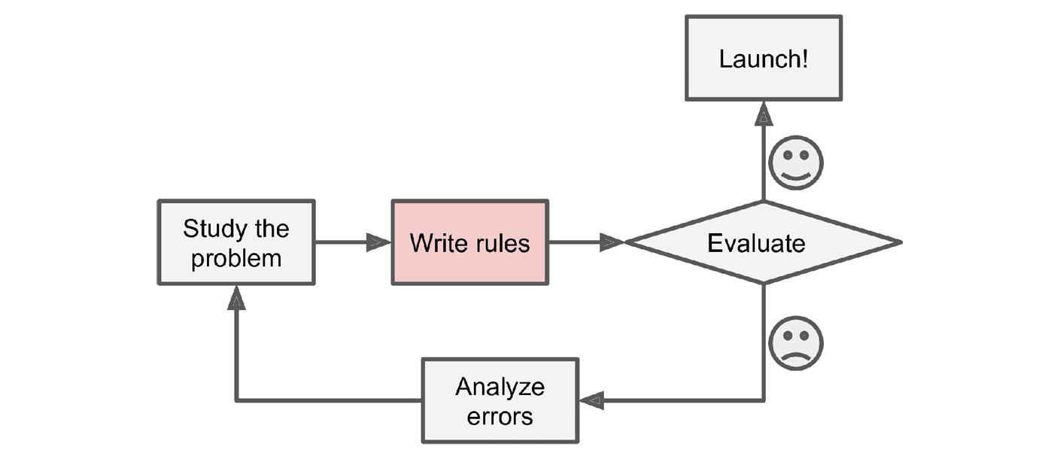
Figure 1. 1 The traditional approach
Traditional Programming:
- Method Programmers write a long, complex list of explicit rules (e.g., IF email contains "4U," THEN spam).
- Adaptation Requires manual intervention; if patterns change (e.g., from "4U" to "For U"), the programmer must rewrite the rules.
- Maintenance Difficult and time-consuming due to the rigid and extensive nature of the ruleset.
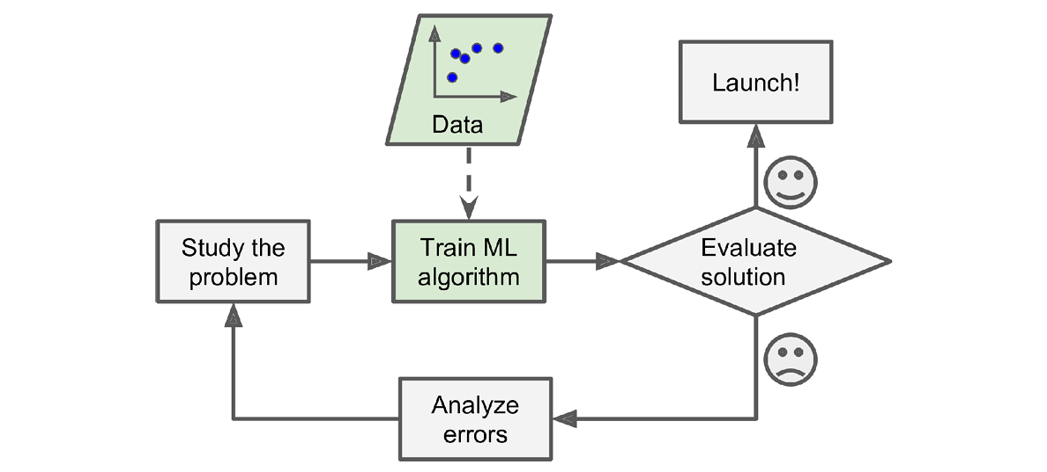
Figure 1. 2 The Machine Learning approach
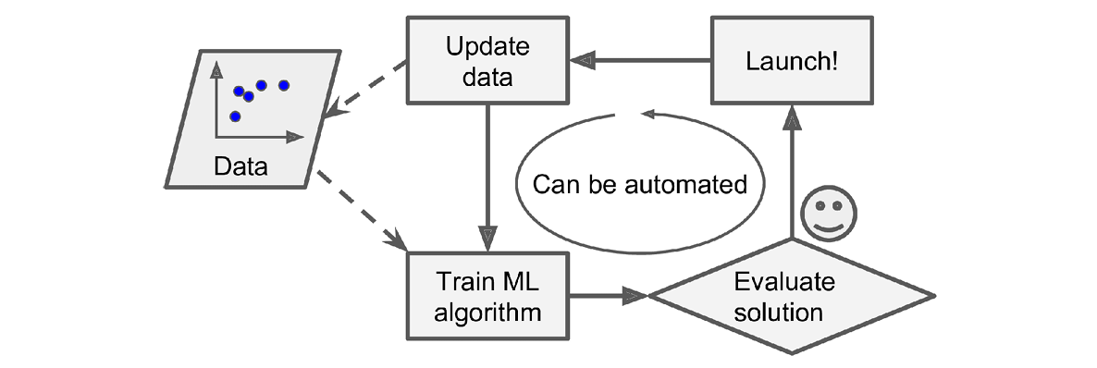

Figure 1. 3 Automatically adapting to change
Machine Learning:
- Method The algorithm automatically learns patterns and predictors by analyzing the training data.
- Adaptation Adapts automatically to new data and changing trends without programmer intervention.
- Maintenance Generally results in shorter, more manageable code because the complexity is handled by the data and the learning algorithm.

Why ML is Powerful?
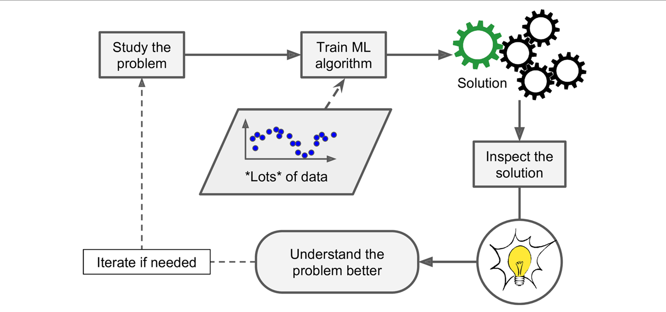
Figure 1. 4 Machine Learning can help humans learn
Machine Learning is highly beneficial for:
- Complex Problems: It provides solutions to problems that are too complicated for traditional programming (e.g., speech recognition).
- Fluctuating Environments: Systems can quickly adapt to new data or shifting trends.
- Gaining Insights: ML can reveal unexpected correlations in large datasets (known as data mining), helping humans better understand problems.
EXAMPLES OF APPLICATIONS
Machine Learning is used for a wide variety of complex tasks, which can be grouped based on their focus:
- Computer Vision and Imaging
  - Product image classification and tumor detection in brain scans (semantic segmentation) are handled by Convolutional Neural Networks (CNNs).
- Natural Language Processing (NLP)
  - News article classification and offensive comment detection (text classification), as well as document summarization (text summarization), are commonly performed using Recurrent Neural Networks (RNNs), CNNs, or Transformers.
  - Building a chatbot involves broader NLP components such as Natural Language Understanding (NLU) and Question-Answering modules.
- Value and Sequence Prediction
  - Revenue forecasting is a regression task, which can be solved with models such as Linear Regression, SVM, Random Forests, or Artificial Neural Networks (ANNs). If the data is a time series, RNNs or Transformers are typically used.
  - Responding to voice commands (speech recognition) also involves processing complex sequences, often with RNNs, CNNs, or Transformers.
- Unsupervised and Specialized Tasks
  - Credit card fraud detection is an Anomaly Detection task.
  - Customer segmentation based on purchasing behavior is a Clustering task.
  - Complex data visualization is done using Dimensionality Reduction techniques.
  - Product recommendations use ANNs trained on purchase sequences.
  - Building intelligent game bots relies on Reinforcement Learning (RL), where an agent learns by maximizing rewards (as applied in AlphaGo).
TYPES OF MACHINE LEARNING SYSTEMS
ML systems are categorized based on three primary, non-exclusive criteria. These classifications can be combined (e.g., an online, model-based, supervised system):
- Training Supervision
  - Determines whether the system is trained with human guidance or "labels."
  - Includes Supervised, Unsupervised, Semisupervised, and Reinforcement Learning.
- Incremental Learning
  - Focuses on whether the system can learn continuously from a stream of incoming data.
  - Includes Online learning (learns incrementally on the fly) versus Batch learning (trained using all data at once).
- Generalization Method
  - Distinguishes how the system makes predictions.
  - Includes Instance-based learning (compares new data points to known data points) versus Model-based learning (detects patterns in the training data to build a predictive model).

SUPERVISED/UNSUPERVISED LEARNING
ML systems are classified into four main categories based on the type of supervision they receive during training:
- Supervised Learning
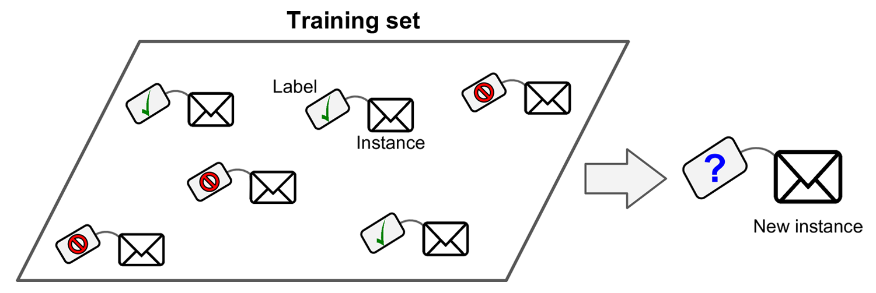
Figure 1. 5 A labeled training set for spam classification (an example of supervised
- Definition: The training set includes the desired solutions, called labels.
- Typical Tasks:
- Classification (e.g., a spam filter that learns to distinguish spam from ham).
- Regression (predicting a numerical target value, such as a car’s price, from input features).
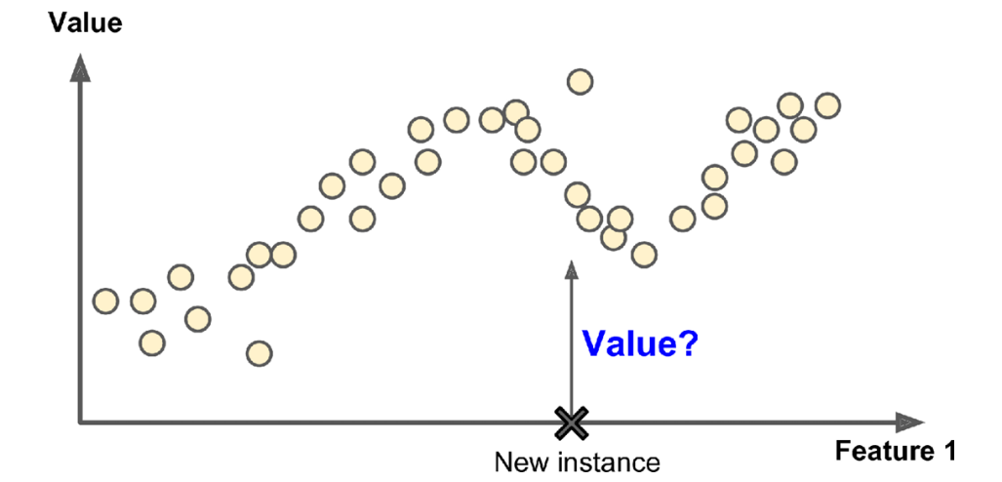
Figure 1. 6 A regression problem: predict a value, given an input feature (there are usually multiple input features, and sometimes multiple output values)
- Example Algorithms: k-Nearest Neighbors, Linear Regression, Support Vector Machines (SVMs), Decision Trees, and Neural Networks.
- Unsupervised Learning
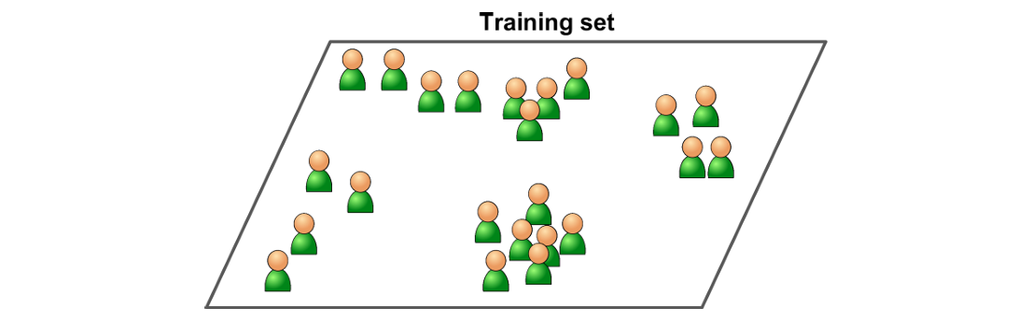
Figure 1. 7 An unlabeled training set for unsupervised learning
- Definition: The training data is unlabeled. The system must discover patterns and structures in the data without guidance.
- Typical Tasks:
- Clustering (grouping similar data, e.g., K-Means, DBSCAN, for visitor segmentation).
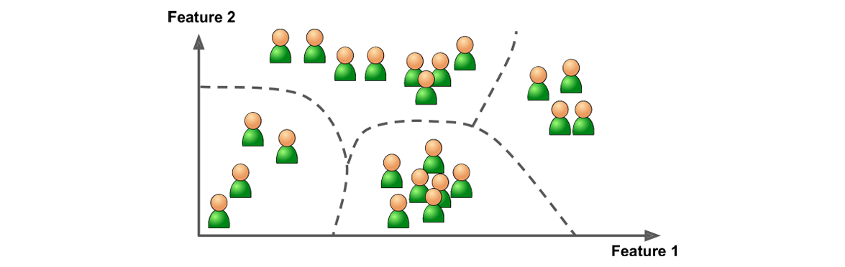
Figure 1. 8 Clustering
- Visualization and Dimensionality Reduction (simplifying complex data into easy-to-plot 2D/3D representations, e.g., PCA, t-SNE). Often used as a preprocessing step (feature extraction).
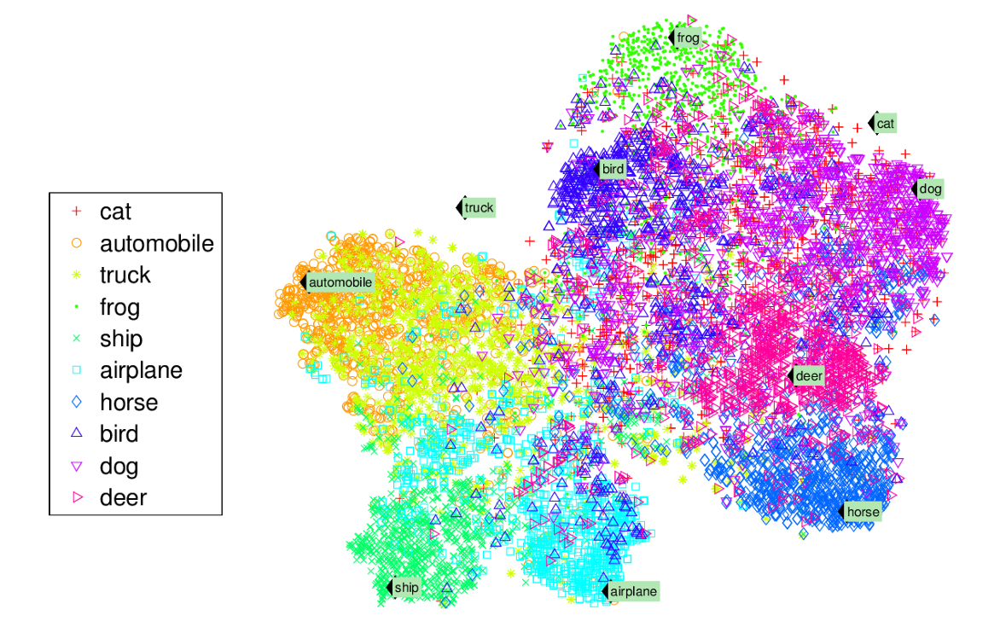
Figure 1. 9 Example of a t-SNE visualization highlighting semantic clusters
- Anomaly Detection (identifying unusual events, e.g., credit card fraud).
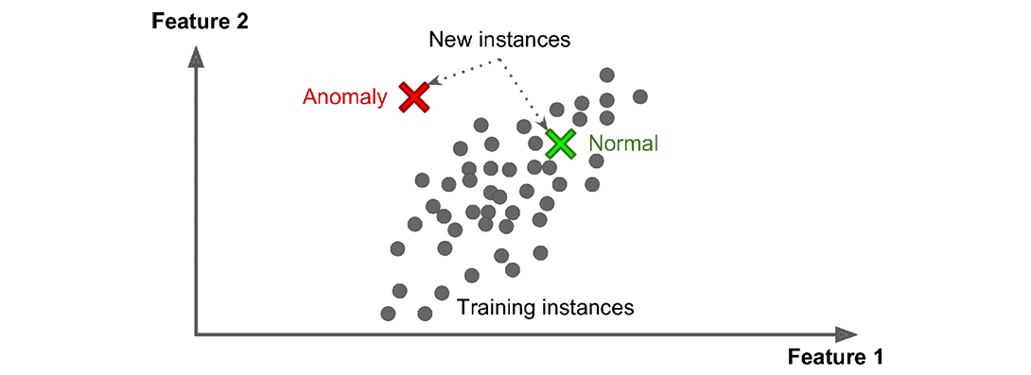
Figure 1. 10 Anomaly detection
- Association Rule Learning (finding relationships between attributes, e.g., products frequently bought together in supermarkets).
- Semisupervised Learning
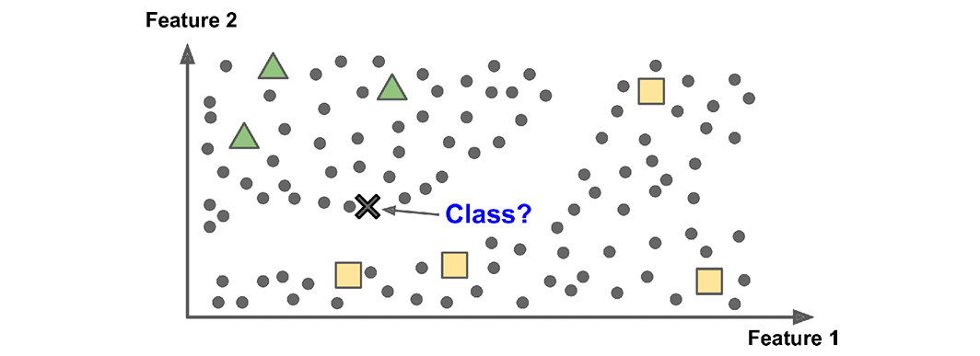
Figure 1. 11 Semisupervised learning with two classes (triangles and squares): the unlabeled examples (circles) help classify a new instance (the cross) into the triangle class rather than the square class, even though it is closer to the labeled squares
- Definition: Uses a combination of large amounts of unlabeled data and a small amount of labeled data (since labeling is costly and time-consuming).
- Example: A photo service that uses clustering (unsupervised) to group faces, then only needs one user-provided label to name all photos of that person (supervised).
- Implementation: Typically a combination of unsupervised and supervised algorithms (e.g., Deep Belief Networks).
- Reinforcement Learning
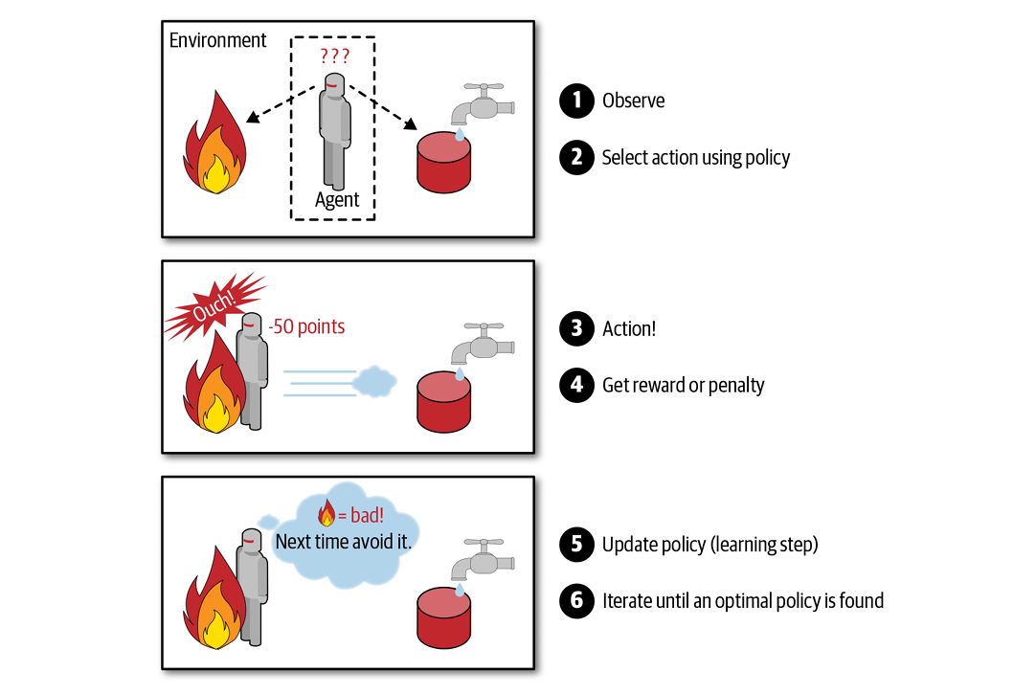
Figure 1. 12 Reinforcement Learning
- Definition: The system, called an agent, observes the environment, takes actions, and receives rewards or penalties.
- Goal: The agent must learn the best strategy (policy) to maximize cumulative rewards over time.
- Examples: A robot learning to walk, or AlphaGo learning its winning strategy.
BATCH AND ONLINE LEARNING
This criterion determines whether an ML system can gradually learn from an incoming stream of data or not.
- Batch Learning (Offline Learning)
- Definition: The system cannot learn incrementally. The model must be trained on all available data at once (batch).
- Process: Training is time-consuming and computationally expensive, so it is performed offline. The trained model is then deployed to production and only applies what it has learned, without further learning.
- Adaptation: To incorporate new data, a new version of the system must be retrained from scratch on the entire dataset (old + new). This process is costly and slow (e.g., it can only be performed daily or weekly).
- Weaknesses: Not suitable for rapidly changing data (e.g., stock prices) or for very large datasets that cannot fit into a single machine’s memory.
- Online Learning (Incremental Learning)
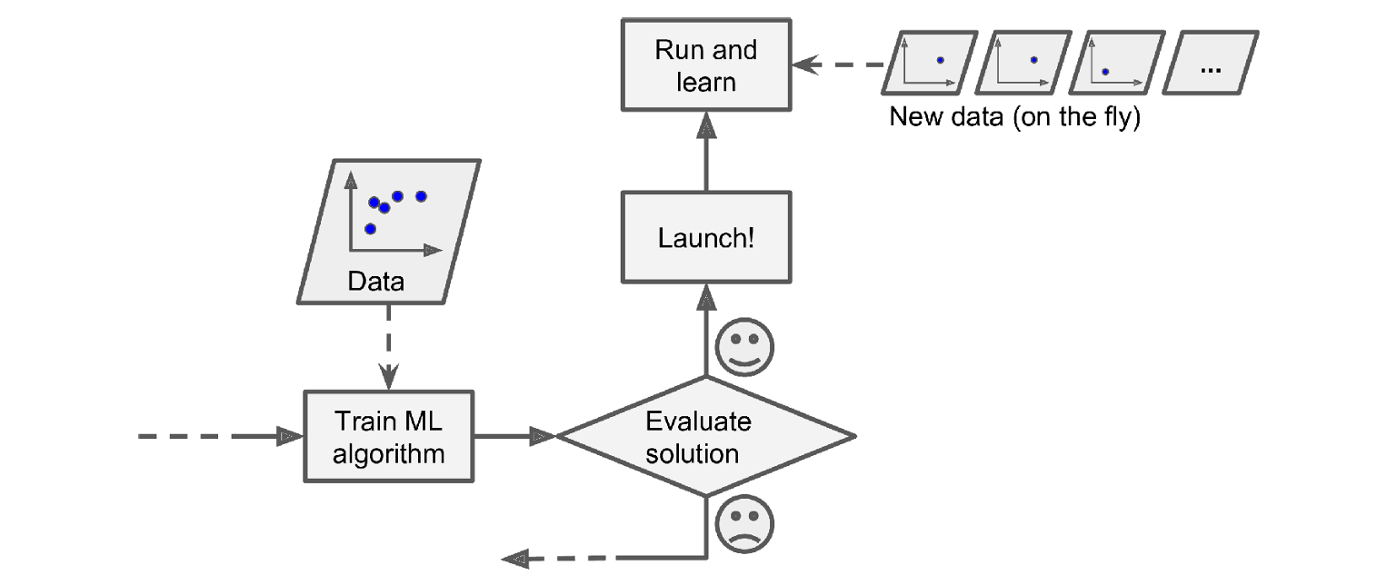
Figure 1. 13 In online learning, a model is trained and launched into production, and then it keeps learning as new data comes in
- Definition: The system is trained incrementally by receiving data instances sequentially, either one by one or in mini-batches.
- Process: Each learning step is fast and inexpensive. The system can learn from new data on the fly as it arrives.
- Advantages:
- Ideal for continuously streaming data.
- Useful for systems that must adapt quickly or autonomously.
- Suitable for datasets too large to fit into memory (known as out-of-core learning).
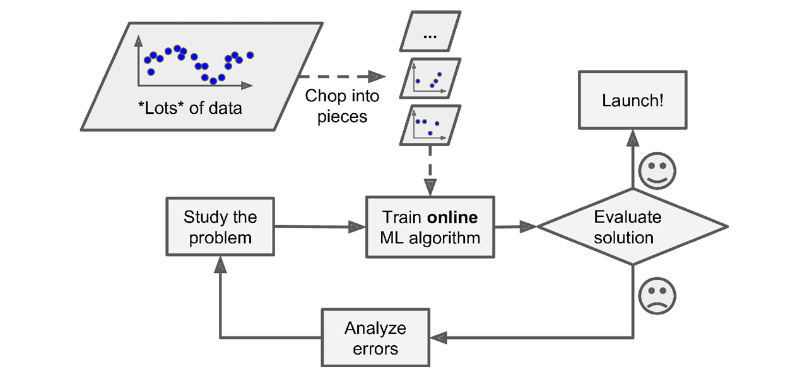
Figure 1. 14 Using online learning to handle huge datasets
- Old data can be discarded once learned, saving storage space.
- Challenges:
- Sensitive to bad data, which may cause performance to degrade gradually.
- Requires careful monitoring and an appropriate learning rate:
- High Learning Rate: Adapts quickly to new data but tends to forget old data fast.
- Low Learning Rate: Adapts more slowly but is more robust to noise or outliers.
INSTANCE BASED VERSUS MODEL BASED LEARNING
- Instance Based Learning
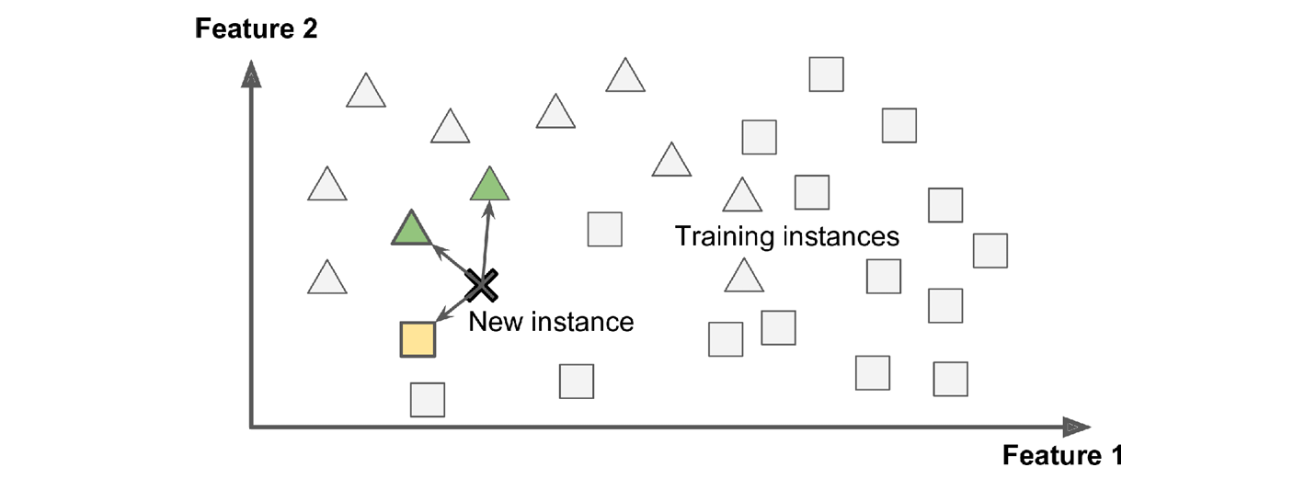
Figure 1. 15 Instance Based Learning
- Method The system learns by memorizing the training examples by heart.
- Generalization It generalizes to new cases by using a similarity measure to compare the new data point to the stored examples (or a subset of them).
- Analogy Like looking up a new item by comparing it to the closest match in a mental library.
- Example The k-Nearest Neighbors algorithm, which classifies a new instance based on the majority class of its k nearest neighbors.
- Model Based Learning
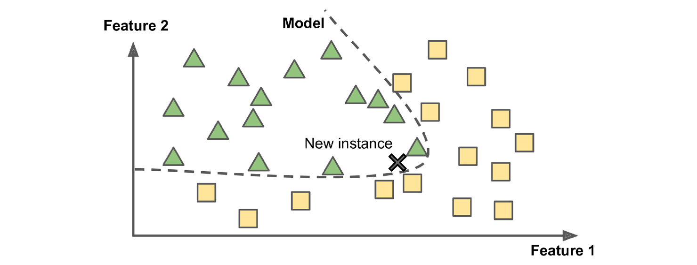
Figure 1. 16 Model Based Learning
- Method The system detects patterns in the training data to build a predictive model and then uses that model to make predictions.
- Workflow This process typically involves several steps:
- Model Selection Choosing a model type (e.g., a linear model like life_satisfaction = θ₀ + θ₁ × GDP_per_capita).
- Cost Function Defining a measure (cost function) of how "bad" the model's predictions are. The goal is to minimize this cost.
- Training Running a learning algorithm (like Linear Regression) to find the optimal model parameters (e.g., values for θ₀ and θ₁) that best fit the training data.
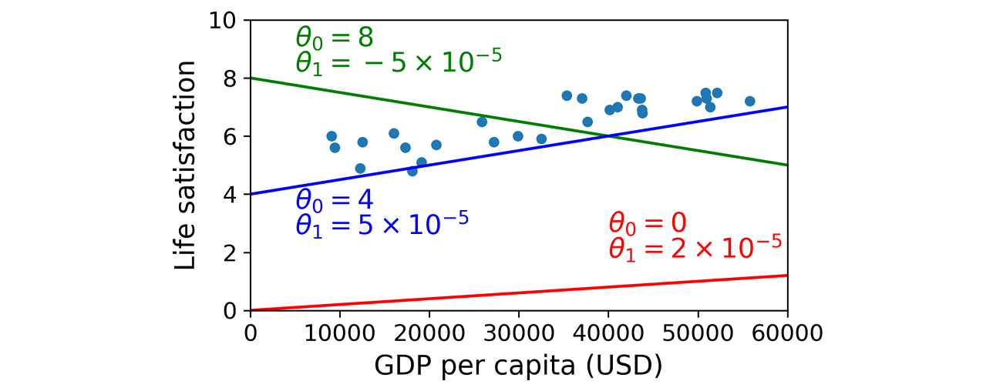
Figure 1. 17 A few possible linear models
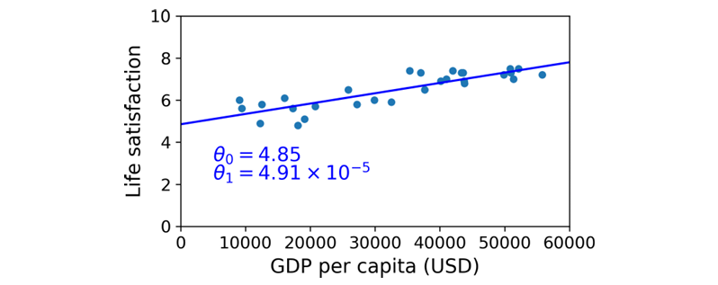
Figure 1. 18 The linear model that fits the training data best
- Inference Applying the final trained model to make predictions on new instances.
- Typical ML Project Summary
A standard Machine Learning project follows this flow: Study the Data - Select a Model - Train the Model (finding parameters that minimize the cost) - Apply the Model to make predictions (inference).
MAIN CHALLENGES OF MACHINE LEARNING
Challenges in ML projects are generally divided into two major problems: poor data and poor algorithms.
- Poor Data Problems
Machine Learning relies heavily on the quality of training data. Common poor data issues include:
- Insufficient Quantity of Training Data
- Nonrepresentative Training Data
- Poor Quality Data
- Irrelevant Features
INSUFFICIENT QUANTITY OF TRAINING DATA
Modern ML relies heavily on data; thousands of examples are needed for simple problems, and millions for complex ones (such as image or speech recognition) a stark contrast to the rapid learning ability of young children.
The Importance of Data (The Unreasonable Effectiveness of Data)
- Data > Algorithms: Research has shown that when provided with sufficient data (very large corpora), even relatively simple and different ML algorithms can achieve nearly the same performance on complex problems (e.g., natural language disambiguation).
- Investment Priority: This suggests that ML practitioners may need to reconsider their priorities—investing time and resources in developing data corpora (datasets) may be more beneficial than focusing solely on algorithm development.
- Note: However, for small- to medium-scale datasets, which are still very common, strong algorithm design remains important since acquiring additional data is not always easy or cost-effective.
POOR QUALITY DATA
If the training data is full of errors, outliers, or noise, the model will struggle to identify underlying patterns. Solutions include removing outliers or filling in missing values with median values. In practice, most of a data scientist’s time is spent cleaning data.
IRRELEVANT FEATURES
The principle “Garbage In, Garbage Out” applies: a system can only learn if it is provided with sufficiently relevant features. This process is called Feature Engineering, which includes:
- Feature Selection: choosing the most useful features.
- Feature Extraction: combining existing features into more informative ones (often assisted by Dimensionality Reduction).
OVERFITTING THE TRAINING DATA
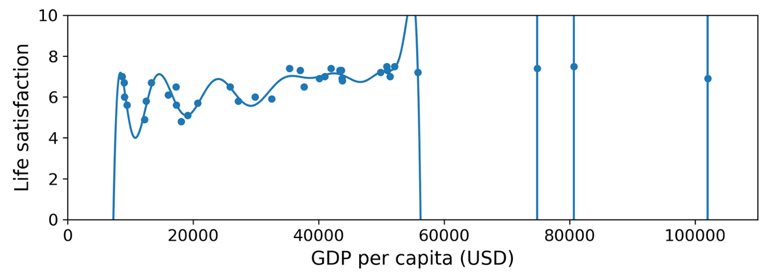
Figure 1. 19 Overfitting the training data
- Definition: The model is too complex and ends up learning noise or random patterns in the training data, failing to generalize to new cases (like assuming all taxi drivers are thieves after one bad experience).
- Causes: Model complexity is too high relative to the amount of training data and its noise level.
- Solutions:
- Simplify the model: choose one with fewer parameters or reduce the number of features.
- Apply Regularization: constrain the model to keep it simpler. A hyperparameter controls the degree of regularization.
- Gather more training data or reduce noise in the dataset.
UNDERFITTING THE TRAINING DATA
- Definition: The model is too simple to capture the underlying structure of the data, leading to poor predictions even on the training set itself (e.g., using a linear model for an obviously nonlinear phenomenon).
- Solutions:
- Choose a more powerful model (with more parameters).
- Provide better features (feature engineering).
- Reduce constraints on the model (e.g., lower the regularization hyperparameter).
TESTING AND VALIDATION
To ensure the model generalizes well, data is split into:
- Training Set: Used to train the model (e.g., 80% of the data).
- Test Set: Used to measure Generalization Error (error rate on new cases) as an estimate of final performance.
- If training error is low but generalization error is high, the model is overfitting.
- Validation Set: Used to evaluate and select the best model (including tuning hyperparameters) among several candidates, preventing repeated use of the test set (which would otherwise cause overfitting to the test set itself).

